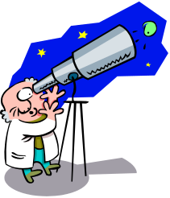
The Altitude of Polaris

Problem: How does the shape of the earth affect our view of the stars?

VOCABULARY: PLEASE DEFINE
1. Altitude _______________________________________________________________
2. Polaris ________________________________________________________________
3. Horizon _______________________________________________________________

OBSERVATIONS:

Label the Big Dipper, Polaris, and Cassiopeia on the picture below:

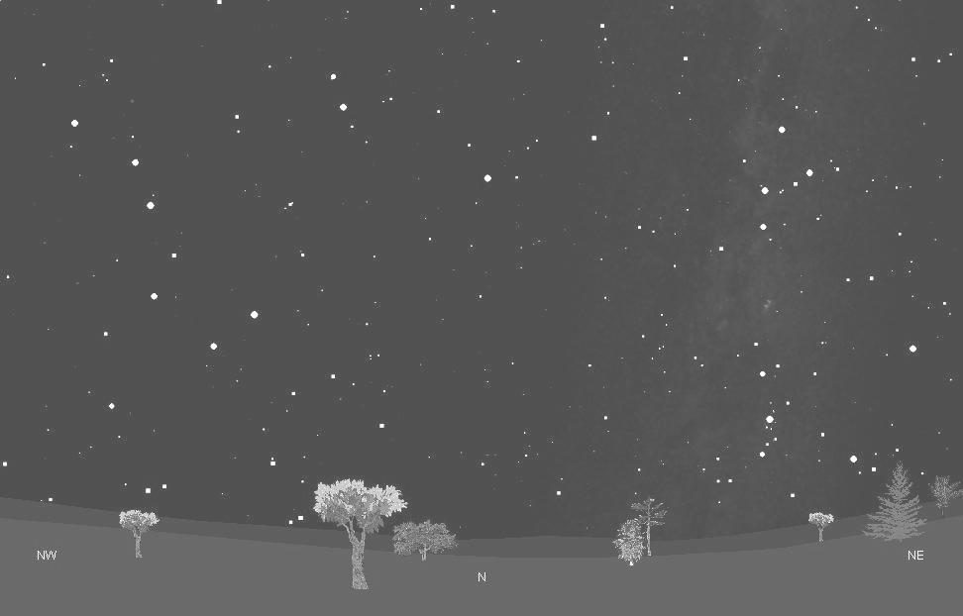

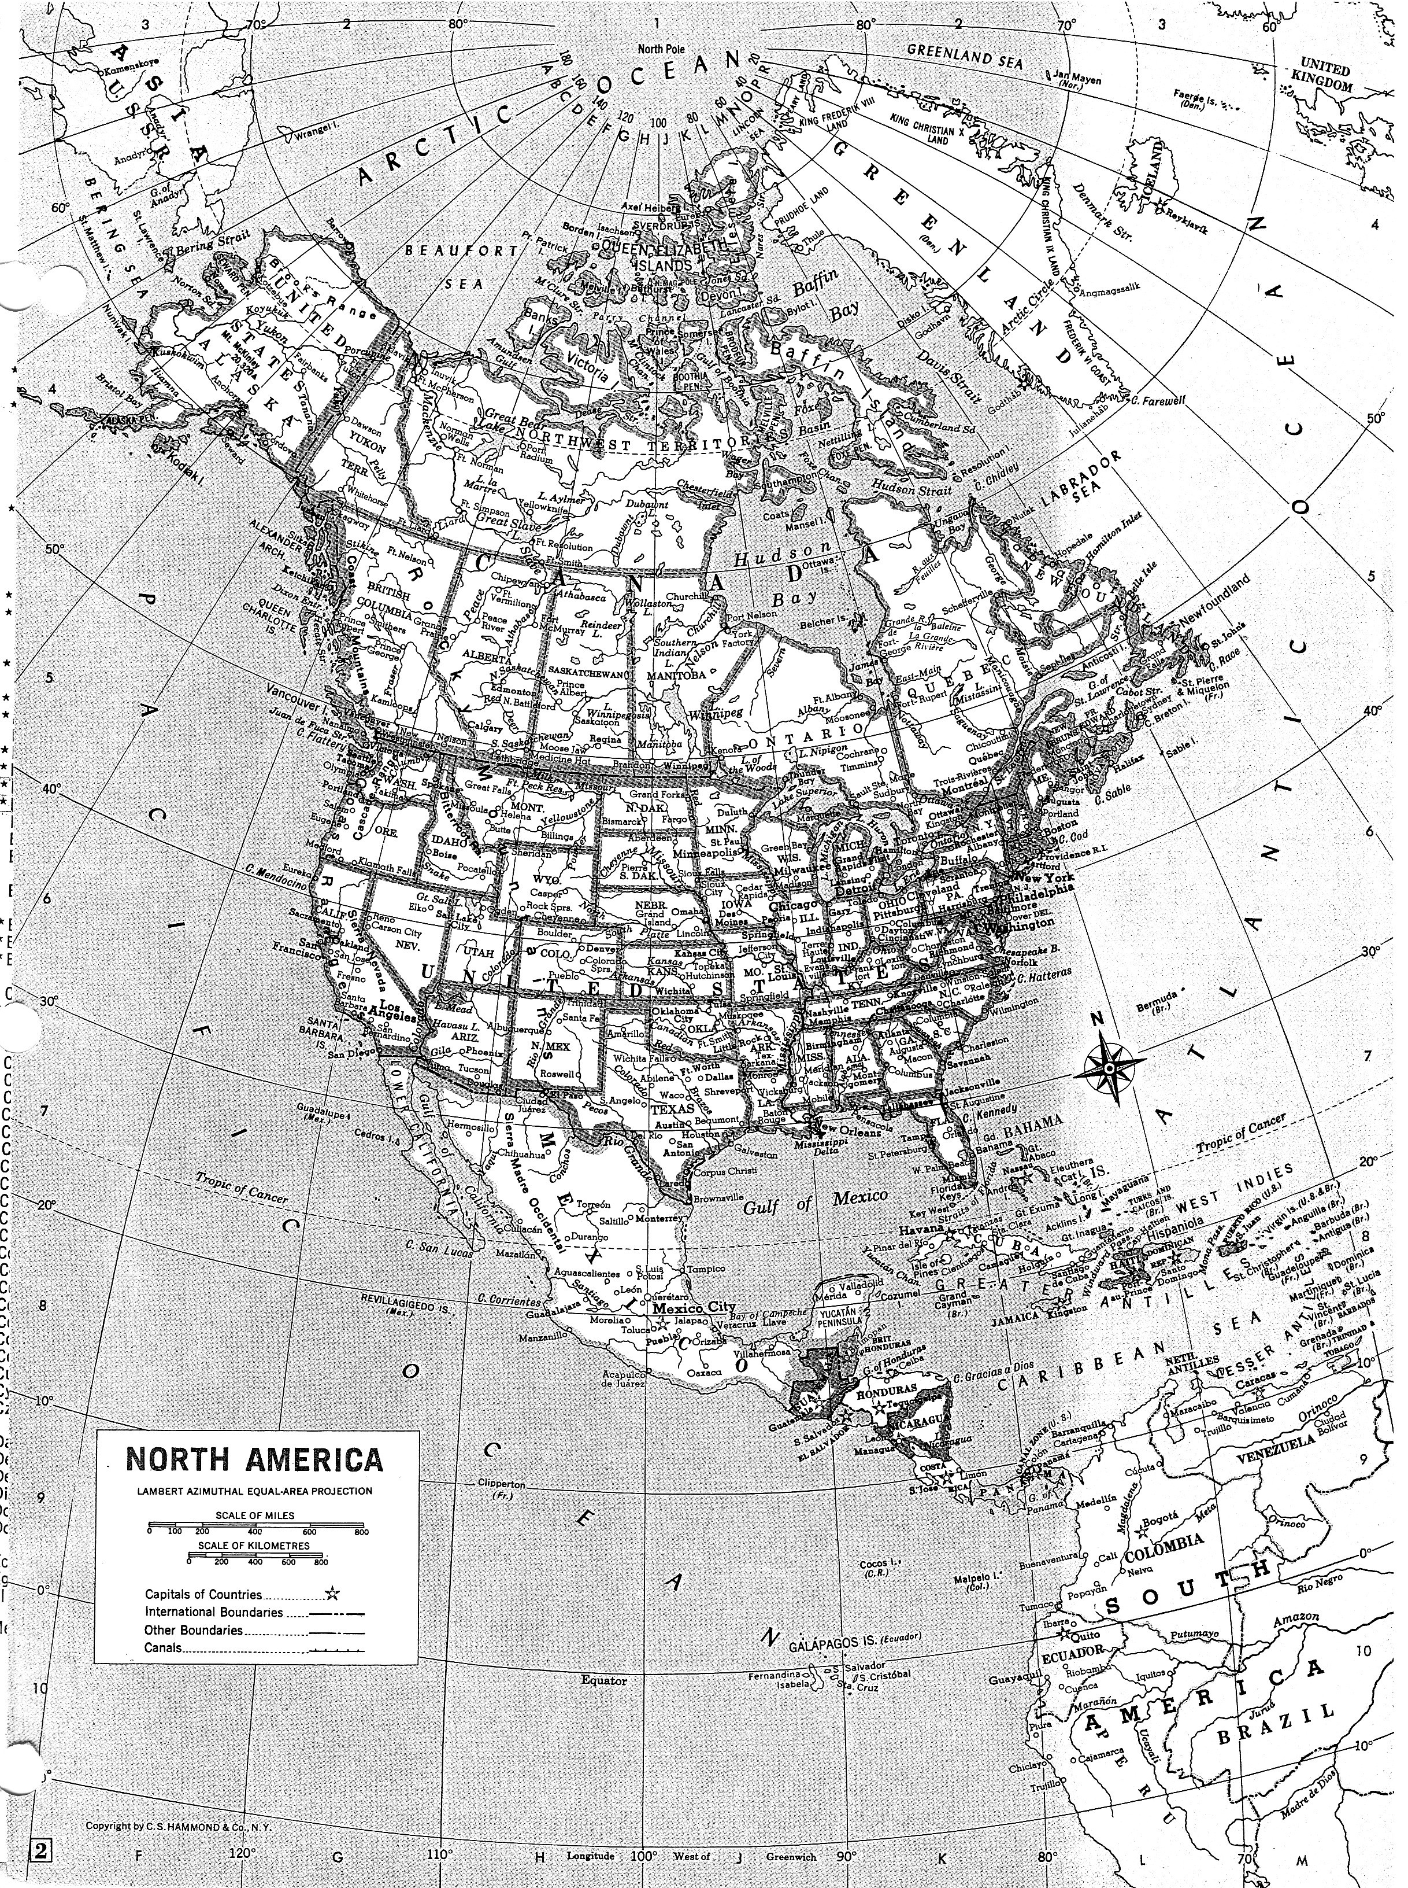
Using a colored pencil, circle the locations we visit on Earth. Use this map to find the latitude of each location we visit.

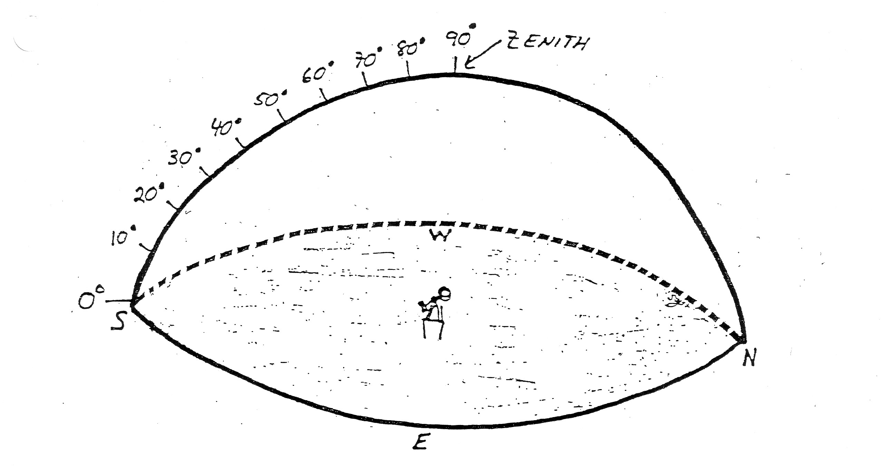
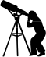
E
N
0º
0º
E
#1
#2
Location:____________
Latitude: ____
Location:____________
Latitude: ____

S
N
S

W
W

ALTITUDE OF POLARIS AT 6 DIFFERENT LOCATIONS ON EARTH
#3
#4

Location:____________
Latitude: ____
Location:____________
Latitude: ____

0º
E
E

N
N
S
S

W
W
#5
#6

Location:____________
Latitude: ____
Location:____________
Latitude: ____
N
N
S
S
W
W
E
E

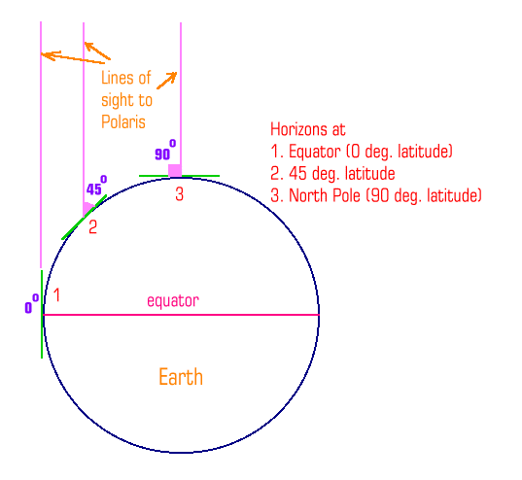
DATA TABLE OF LOCATIONS VISITED
Location | Latitude | Altitude of Polaris

Write a summary of how this activity answers the question, “How does the shape of the earth affect our view of the stars” Be sure to include the following: (Each bullet should have its own paragraph)

- Introduction: Summarize all you have learned about Polaris. Be sure to include what is Polaris, what is its position relative to earth, what constellations help us find it and what characteristic made Polaris so useful for navigation.
- What conclusion can you make about the altitude of Polaris and the latitude of the observer in the Northern Hemisphere? Use specific examples from your data table. Make sure you include the definition of altitude in your discussion.
- What type of relationship (positive, negative, or none) exists between the altitude of Polaris and the latitude of the observer?
- Compare and contrast an observer’s view of Polaris in Popayán, Colombia with an observer in New York. In addition, how does a New Yorker’s view of Polaris compare and contrast with a person’s view from Quebec, Canada?
- Use the diagram above to help explain why an observer cannot see Polaris in the Southern Hemisphere. If the earth were “flat”, would an observer view Polaris at different altitudes? Why or why not?

