Name:___________________________________________________ Date: _____________________
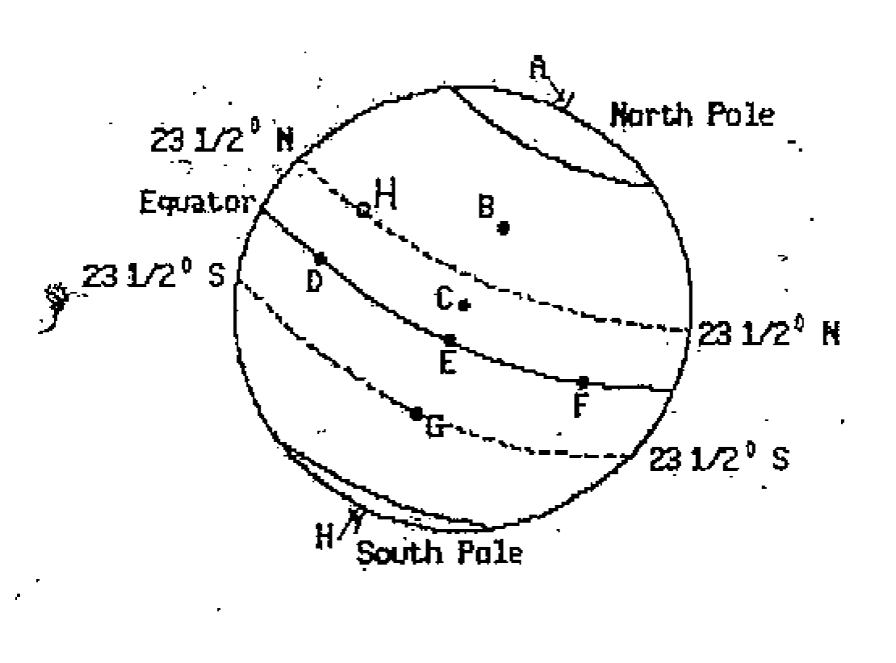
Getting Familiar With Diagrams
- What location is the altitude of Polaris the greatest? __________________

- What 2 liocations are you able to view Polaris? ________ and _________

- Locaiton G is called the:
___________ _______________

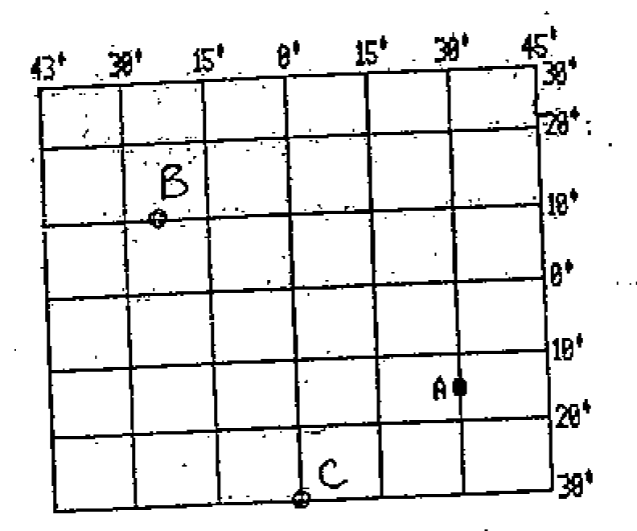
- Location H Is called the:
___________________________
- State the Latitude and Longitude for the following locations:

A.________________________________

B:________________________________

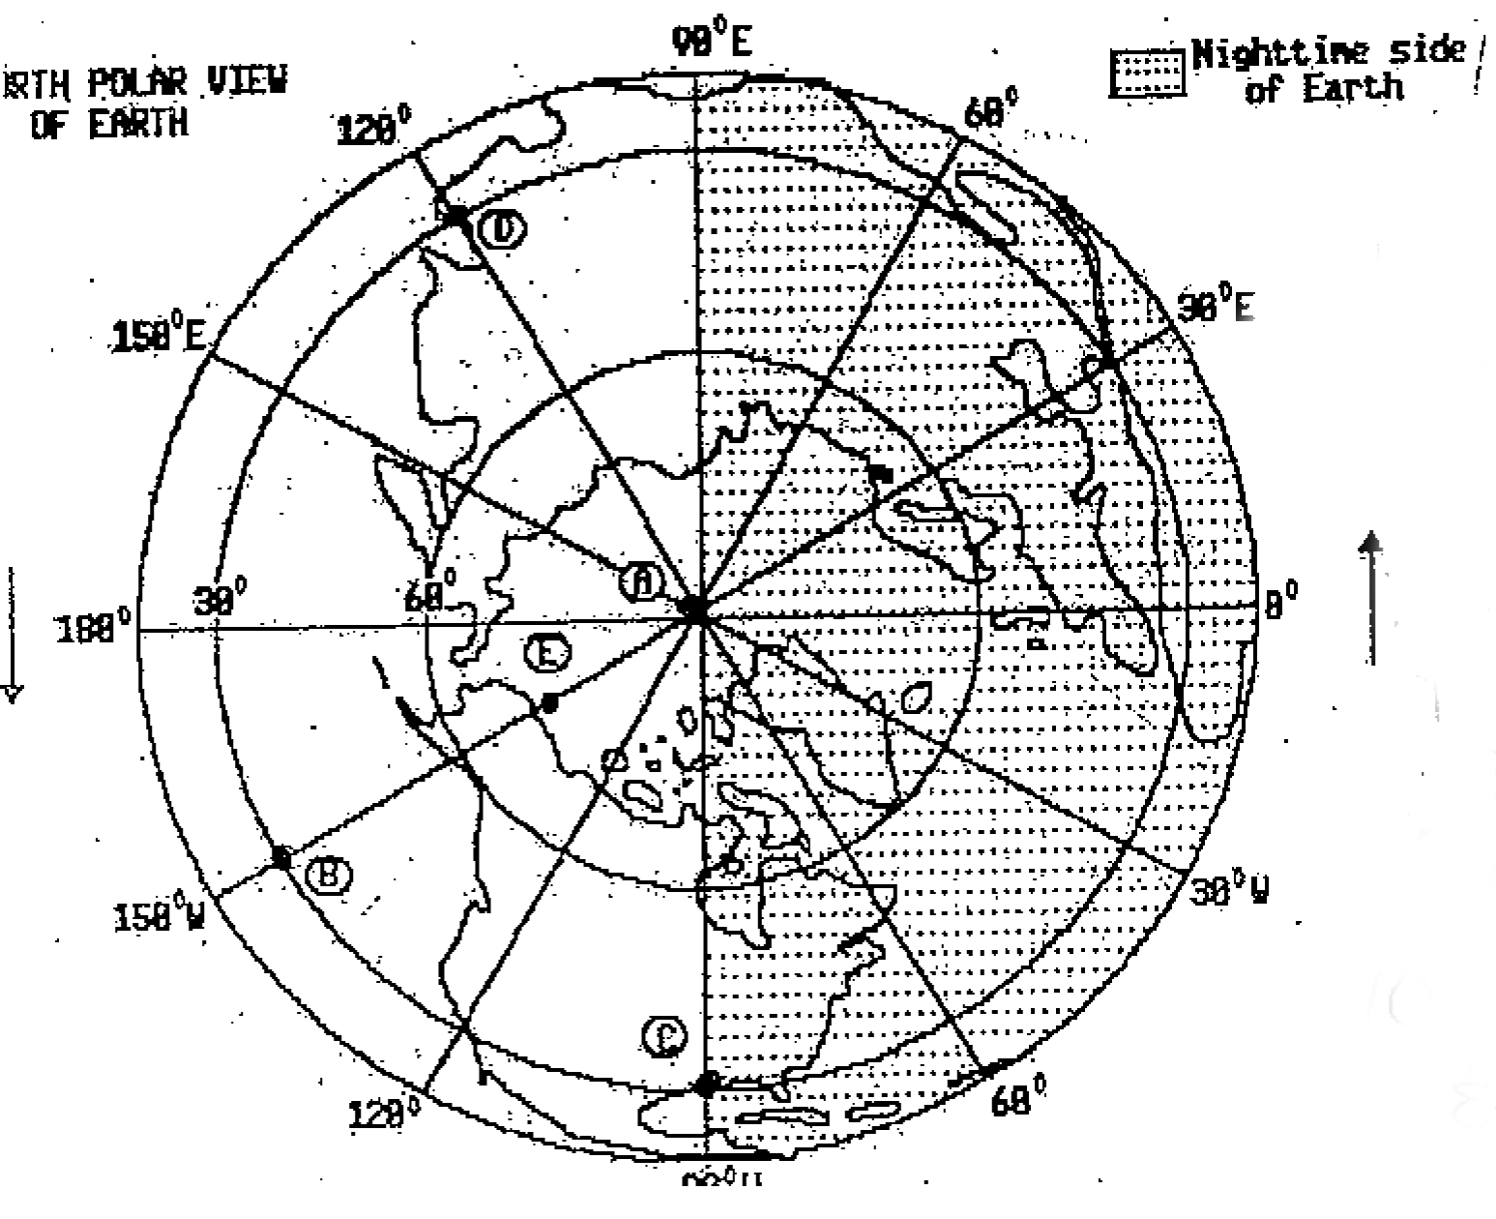
C:________________________________

- Location A is called the: __________________
_____________________________________

- Locations B, C and D have the same: _____________________________________

- Which location can you view polaris with the greatest altitude? _______________________

- Shade in the USA.

- Highlight the Prime Meridian and the International Date Line.

