Name: ______________________________________ Date:_______________
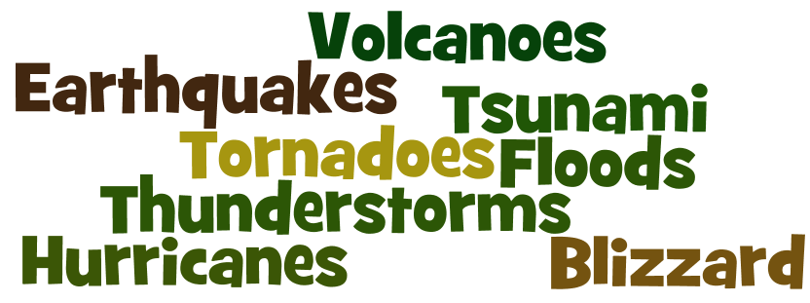
Be Ready. Natural Disaster Preparation

Research and record the preparations for the disasters above. Use FEMA website -> www.ready.gov/natural-disasters
Natural Disaster | Preparation (The “Before” Tab)
1. Earthquakes | 1.
 | 2.
2. Floods | 1.
 | 2.
3. Hurricanes | 1.
 | 2.
4. Thunderstorms | 1.
 | 2.
5. Tornadoes | 1.
 | 2.
6. Tsunamis | 1.
 | 2.
7. Volcanoes | 1.
 | 2.
8. Winter Storms (Blizzards) | 1.
 | 2.

Using the FEMA website, look at the tabs under each disaster and answer the following questions.
1. Once you have evacuated from a volcano warning, what gravity erosional feature should you avoid? __________________________________________________________________________________________________
2. If you are outdoors during an earthquake, should you go inside or stay outside? Why? _________________________
__________________________________________________________________________________________________
3. Before a tsunami occurs, it is important to set up a “safe location” to go to that is at least 2 miles from the shore. It should take you no longer then ______ minutes to reach this location.
4. A person living in a high-rise building should be below the _____ floor during a hurricane.
5. List 3 warning signs of a tornado. 1._______________________________________________________________
2._______________________________________________________________
3._______________________________________________________________
6. After a flood, moving water is still dangerous. 6 inches of water can be dangerous in two ways.
1._______________________________________________________________
2._______________________________________________________________
7. What is the 30/30 rule for Thunderstorms and Lightning? _________________________________________________
__________________________________________________________________________________________________
8. What is the major cause of death during a Winter Storm? _________________________________________________

