Name Date _

DIAGNOSTIC TEST TOPIC 1 (CONTINUED)

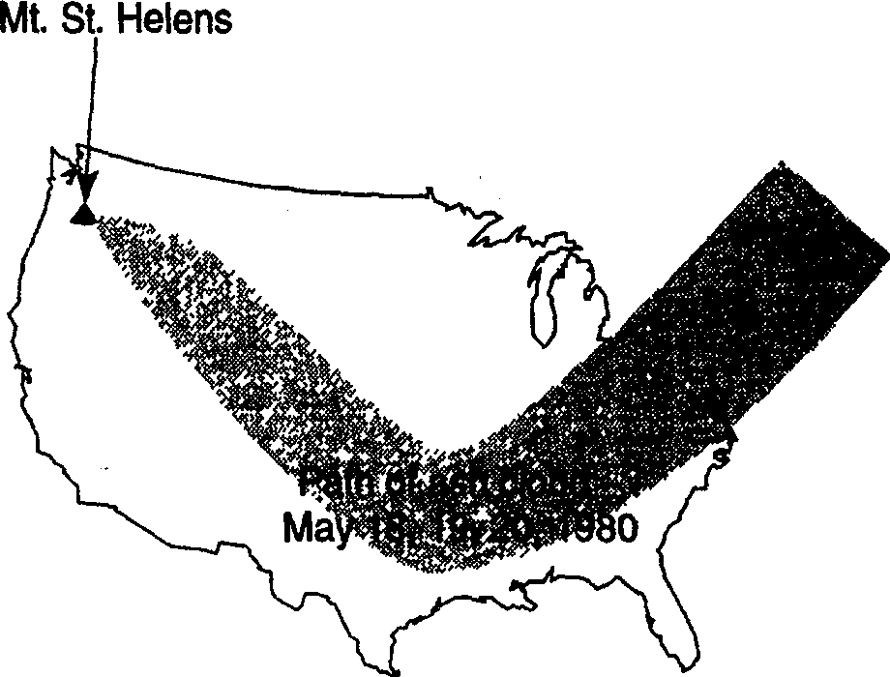Base your answer to question 6 on the passage below and on your knowledge of earth science.

A Newly Discovered Planet
Scientists studying a Sun-like star named Ogle-Tr-3 discovered a planet that is, on the average, 3.5 million kilometers away from the star's surface. The planet was discovered as a result of observing a cyclic decrease in the brightness of Ogle-Tr-3 every 28.5 hours. The changing brightness is the result of the planet blocking some of the starlight when it is between Ogle-Tr-3 and Earth. This. observation allowed scientists to find not only the planet, but also to determine the planet's mass and density. The mass has been calculated to be approximately
159 times the mass of Earth. The planet is only
20% as dense as Jupiter. Scientists think that
this low density is the result of being very close to Ogle-Tr-3.

6. The density of the discovered planet has been estimated to be approximately
(1) 5.5 g/cm3 (3) 1.3 g/cm3
(2) 2.0 g/cm3 (4) 0.3 g/cm3

7. Scientists can plan to photograph a solar eclipse because most astronomical events are
(1) cyclic and predictable

The path of the ash cloud was most probably determined by
(1) hypothesis (3) theory
(2) inference (4) observation

10. The graph below shows the relationship between mass and volume for three samples, A, B, and C, of a given
material

35
1/
I c u
30
v E
-
c:
25

(2) cyclic and unpredictable
(3) random and predictable
(4) random and unpredictable

8. A student is asked to classify several rocks. For best results, the classification should be based on
(1) inferences (3) hypotheses
(2) interpretations . (4) observations

9. The map that follows shows the path of an ash cloud that resulted from the Mount St. Helens volcanic eruption. The map was developed from satellite photographs.

2 EARTH SCIENCE ANSWER KEY
s 20
0
0
i
15
I

10
I
A
v
5

0
0 1 2 3 4 5
Volume(cm,

What is the density of this material? (1) 1.0 g/cm3 (3) 10.0 g/cm3
(2) 5.0 g/cm3 (4) 20.0 g/cm3

u
IB
:::l
"w0
c:
0
ro
&

Cl

0
u

Name Date

DIAGNOSTIC TEST TOPIC 2

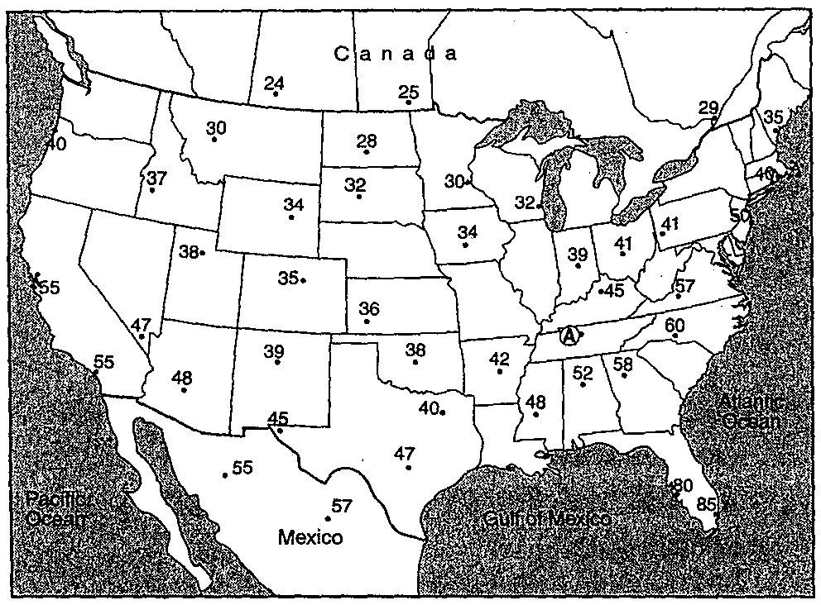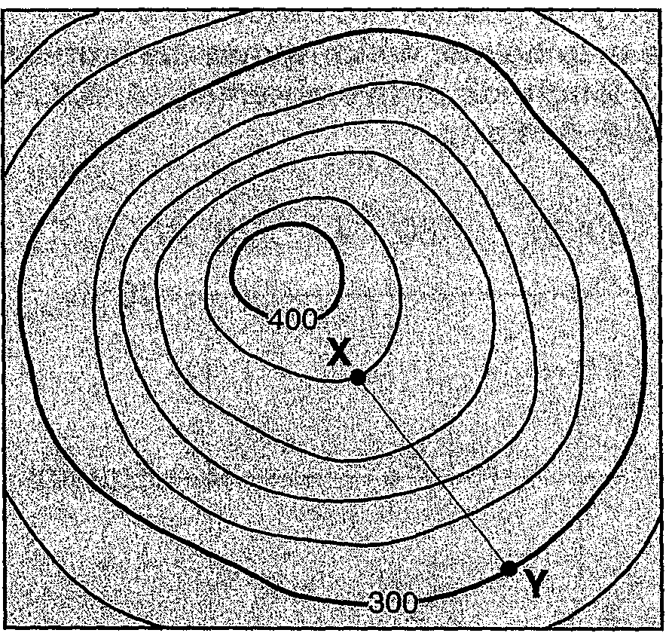Base your answers to questions 1 and 2 on the following temperature field map provided.

The map shows air temperatures, in degrees Fahrenheit, recorded at the same time at weather stations across North America.
The air temperature at location A has been
deliberately left blank.

N
0 1 2km i

What is the gradient between points X
andY?

(1) 40 mJkm
(2) 80 mJkm
(3) 100 m/km
(4) 120 m/km

...
0
u
s:::
s:::'
0
·.;:;
u
:::l
\J
w
c
0

1. On the map provided, use smooth, curved solid lines to draw the 30°F,
40°F, and 50°F isotherms.

2. What is the most probable air temperature at location A?

3. The approximate latitude of Utica, New York, is

5. The diagram below shows an observer on Earth measuring the altitude of Polaris.

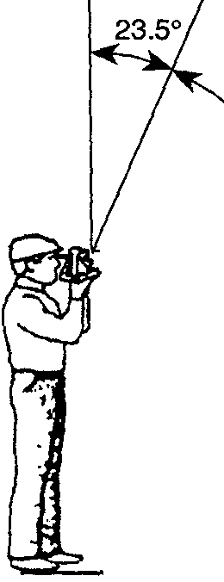Zenith Polaris

66.5°

@
.....
..s:::
·0;:1:
(1) 43°05' N (2) 43°05' s
(3) 75°15' E
(4) 75°15' w
------------- _t19Jj?_QQ_

4. The topographic map that follows
0 shows a hill. Points X and Y represent locations on the hill's surface. Elevations are shown in meters.
u

What is the latitude of this observer?
(1) 90° N (3) 43° N
(2) 66.5° N (4) 23.5° N

EARTH SCIENCE ANSWER KEY 3

Name Date _

DIAGNOSTIC TEST TOPIC 2 (CONTINUED)

Base your answers to questions 6 and 7 on the map below, which shows the latitude and longitude of five observers, A, 8, C, D, and E, on Earth.

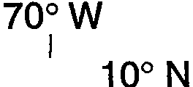80°W A
11. An environmental scientist needs to prepare a report on the potential effects that a proposed surface mine in New York State will have on the watershed where the mine will be located. In which reference materials will the scientist
find the most useful data with which to determine the watershed's boundaries? (1) topographic maps
(2) geologic time scales

B c Equator

D E

6. What is the altitude of Polaris (the North Star) above the northern horizon for observer A?

(4) planetary wind maps

12. Which element is most abundant in
Earth's lithosphere?
(1) oxygen (3) hydrogen
(2) silicon (4) nitrogen

13. As a ship crosses the Prime Meridian, an observer on the ship measures the altitude of Polaris at 60°. What is the ship's location?

(1) 0°
(2) 10°
(3) 80°
(4) 90°
(1) 60° south latitude and 0° longitude
(2) 60° north latitude and 0° longitude
(3) oo latitude and 60° east longitude

7. Which two observers would be
experiencing the same apparent solar time?
(4) 0° latitude and 60° west longitude

14. At which New York State location will

....
0

(1) A and C
(2) Band C
(3) B andE
(4) D andE
an observer most likely measure the altitude of Polaris as approximately 42°? (1) Jamestown (3) Oswego

8. When the time of day for a certain ship at sea is 12 noon, the time of day at the Prime Meridian (0° longitude) is 5 p.m. What is the ship's longitude?
(1) 45° w (3) 75° w
(2) 45° E (4) 75° E

9. Which New York State river flows generally southward?
(1) St. Lawrence River
(2) Niagara River
(3) Genesee River
(4) Hudson River

10. Which temperature zone of Earth's atmosphere contains the most water vapor?
(2) Plattsburgh (4) New York City

15. The North Star (Polaris) can be used for navigation in Earth's Northern Hemisphere because
(1) Polaris is located directly over the
Tropic of Cancer
(2) Polaris is the brightest and most
easily located star
(3) the altitude of Polaris is equal to the
observer's latitude
(4) the position of Polaris changes with
the seasons

(1) mesosphere
(2) stratosphere
(3) thermosphere
(4) troposphere

4 EARTH SCIENCE ANSWER KEY

