Topic 3 Review

- The universe began with a big explosion--"The Big Bang".

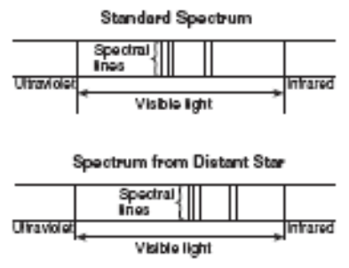
- Our solar system is located on one of the outer arms of our Milky Way Galaxy (Spiral Shape).

- An object speeding away from us will shift the light waves to the longer wavelength – red shift.
Objects coming towards us, the light waves shifted to the shorter wavelength – blue shift due to the Doppler Effect.

- Luminosity = brightness of a star, increases as you go up the HR Diagram (ESRT), depends on size. Bigger = Brighter

- Temp = color, decreases to the right, HR Diagram (ESRT) Blue=Hot, Red=cool

- Our Star = Sun, life cycle=main sequence, red giant, white dwarf (Plot it on HR)

- Star structure = nuclear fusion of Hydrogen(light) into Helium(heavy), balance: thermal pressure(out) and gravity(inward)

- Solar system = everything that revolves around the sun: planets, moons, asteroid belts, comets

- Geocentric – Earth centered model of solar system (out dated)
Heliocentric – Sun centered model of solar system (currently used)

- Aphelion - the point on an orbit farthest from the sun (A – away). Perihelion - the point on an orbit closest to the sun.

- Eccentricity = distance between foci (a perfect circle = 0, a line = 1) Length of major axis (see cover of ref. tables) also (Solar System Data on page 15 ESRT)

- Ellipse (The closer the foci, the closer to a perfect circle (both foci in same spot).)

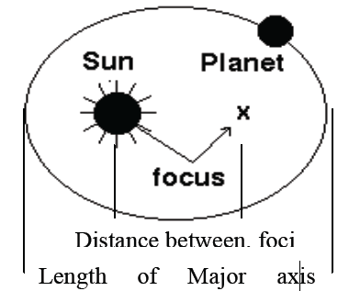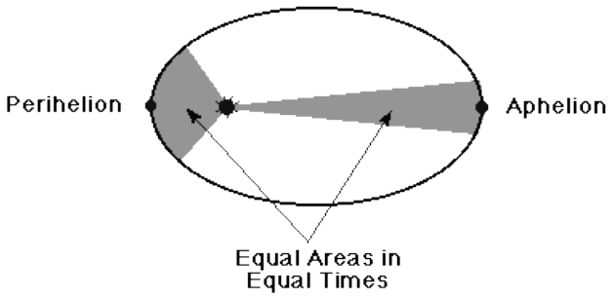

- Earth is closest to the sun in January and farthest in July.

- The earth revolves counterclockwise around the sun (365 1/4 days).

- The closer a planet is to the sun the higher its velocity (the faster it orbits), the larger it appears to be and the greater the gravitational attraction.

- Terrestrial Planets = inner 4 planets, rocky, dense
Jovial Planets = outer 4 planets, gaseous, less dense

- Asteroid Belt located between Mars and Jupiter

